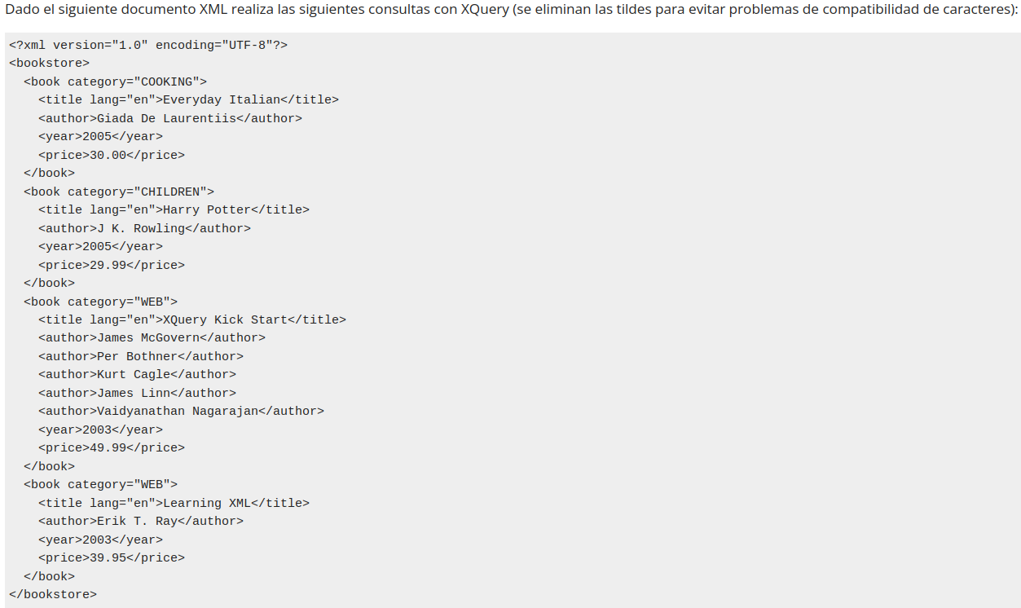

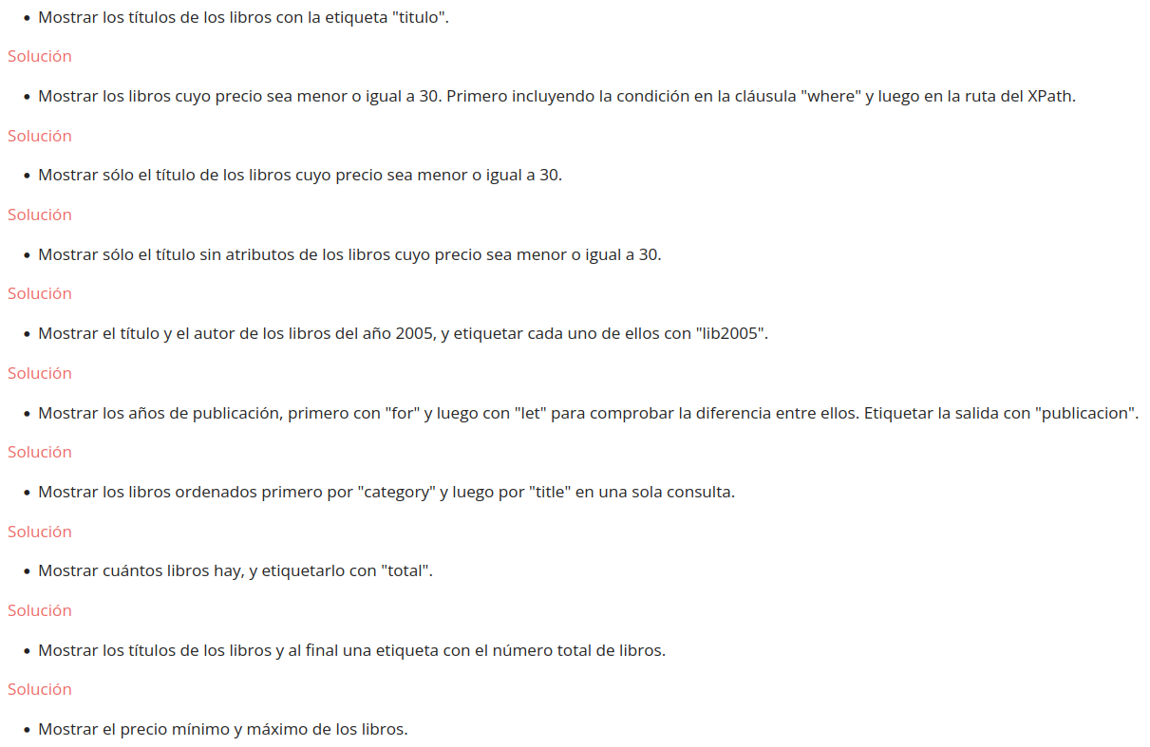

1.
for $b in //bookstore/book
where $b /title
return $b /title

2.
for $b in //bookstore/book
where $b /price <=30
return $b

3.
for $b in //bookstore/book
where $b /price <=30
return $b /title

4.
for $b in //bookstore/book
where $b /price <=30
return <title> {$b /title/text()} </title>

5.
for $b in //bookstore/book
where $b /year = 2005
return <lib2005> <title>{$b /title/text()}</title> <author>{$b /author/text()}</author> </lib2005>

6.1.
for $b in //bookstore/book
return <publicacion>{$b /year}</publicacion>

6.2.
for $b in //bookstore/book
let $y:=$b/year
return <publicacion>{$y}</publicacion>

7.
for $b in //bookstore/book
order by $b /category /title
return $b

8.
let $total := count(//bookstore/book)
return <total>{$total}</total>

9.
let $books := //bookstore/book
let $total := count($books)
return (
for $b in $books
return <title>{$b/title/text()}</title>,
<total>{$total}</total>
)

10.
let $prices := //bookstore/book/price
return (
<minPrice>{min($prices)}</minPrice>,
<maxPrice>{max($prices)}</maxPrice>
)

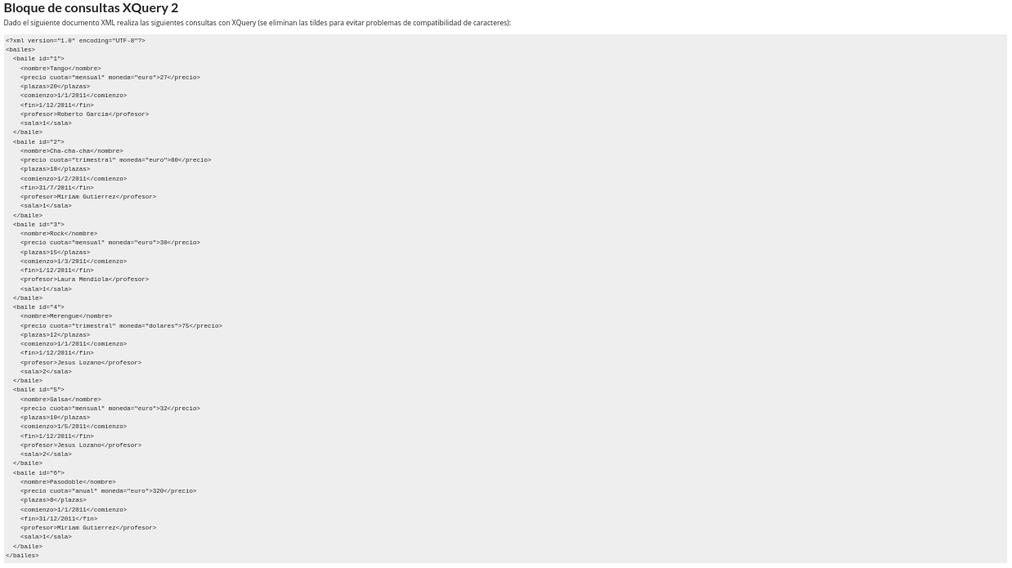
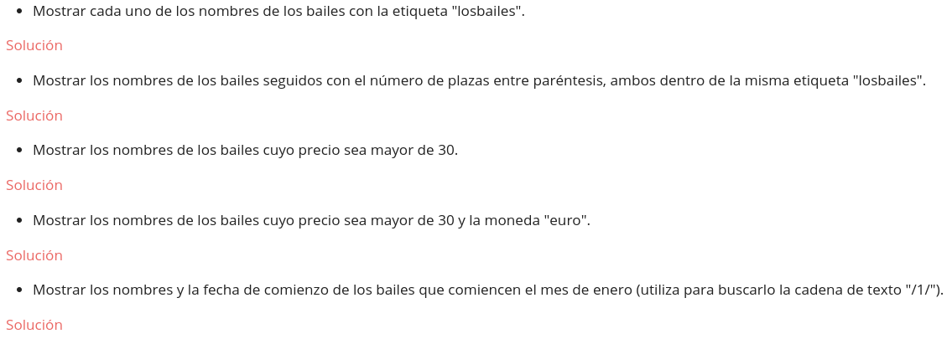

1.
for $b in //bailes/baile
return <losbailes>
<nombre>{$b/nombre/text()}</nombre>
</losbailes>

2.
for $b in //bailes/baile
return <losbailes>
{$b/nombre/text()} ({$b/plazas/text()})
</losbailes>

3.
for $b in //bailes/baile
where $b/precio/text() > 30
return <losbailes>
{$b/nombre/text()}
</losbailes>

4.
for $b in //bailes/baile
where $b/precio/text() > 30 and $b/precio/@moneda = "euro"
return <losbailes>
{$b/nombre/text()}
</losbailes>

5.
for $b in //bailes/baile
where contains($b/comienzo/text(), "/1/")
return <losbailes>
<nombre>{$b/nombre/text()}</nombre>
<comienzo>{$b/comienzo/text()}</comienzo>
</losbailes>

